

Technical Safety Concept Lane Assistance

**Document Version:** 1.0



# Document history

|  |  |  |  |
| --- | --- | --- | --- |
| Date | Version | Editor | Description |
| 12/3/17 | 1.0 | Vatche Donikian | First submission attempt |
|  |  |  |  |
|  |  |  |  |
|  |  |  |  |
|  |  |  |  |

# 

# Table of Contents

Document history

Table of Contents

Purpose of the Technical Safety Concept

Inputs to the Technical Safety Concept

Functional Safety Requirements

Refined System Architecture from Functional Safety Concept

Functional overview of architecture elements

Technical Safety Concept

Technical Safety Requirements

Refinement of the System Architecture

Allocation of Technical Safety Requirements to Architecture Elements

Warning and Degradation Concept

# Purpose of the Technical Safety Concept

The technical safety concept is used to turn functional safety requirements into technical safety requirements, essentially allocating those requirements to the system architecture and involving hardware and software.

# Inputs to the Technical Safety Concept

## Functional Safety Requirements

|  |  |  |  |  |
| --- | --- | --- | --- | --- |
| **ID** | **Functional Safety Requirement** | **ASIL** | **Fault Tolerant Time Interval** | **Safe State** |
| Functional  Safety  Requirement  01-01 | The lane keeping item shall ensure that the lane departure oscillating torque amplitude is below Max_Torque_Amplitude | C | 50 ms | Turn function off |
| Functional  Safety  Requirement  01-02 | The lane keeping item shall ensure that the lane departure oscillating torque frequency is below Max_Torque_Frequency | C | 50 ms | Turn function off |
| Functional  Safety  Requirement  02-01 | The electronic power steering ECU shall ensure that the lane keeping assistance torque is applied for only Max_Duration. | B | 500 ms | Turn function off |

## Refined System Architecture from Functional Safety Concept

The refined system architecture is shown below, with each component of the item allocated with an ASIL score.

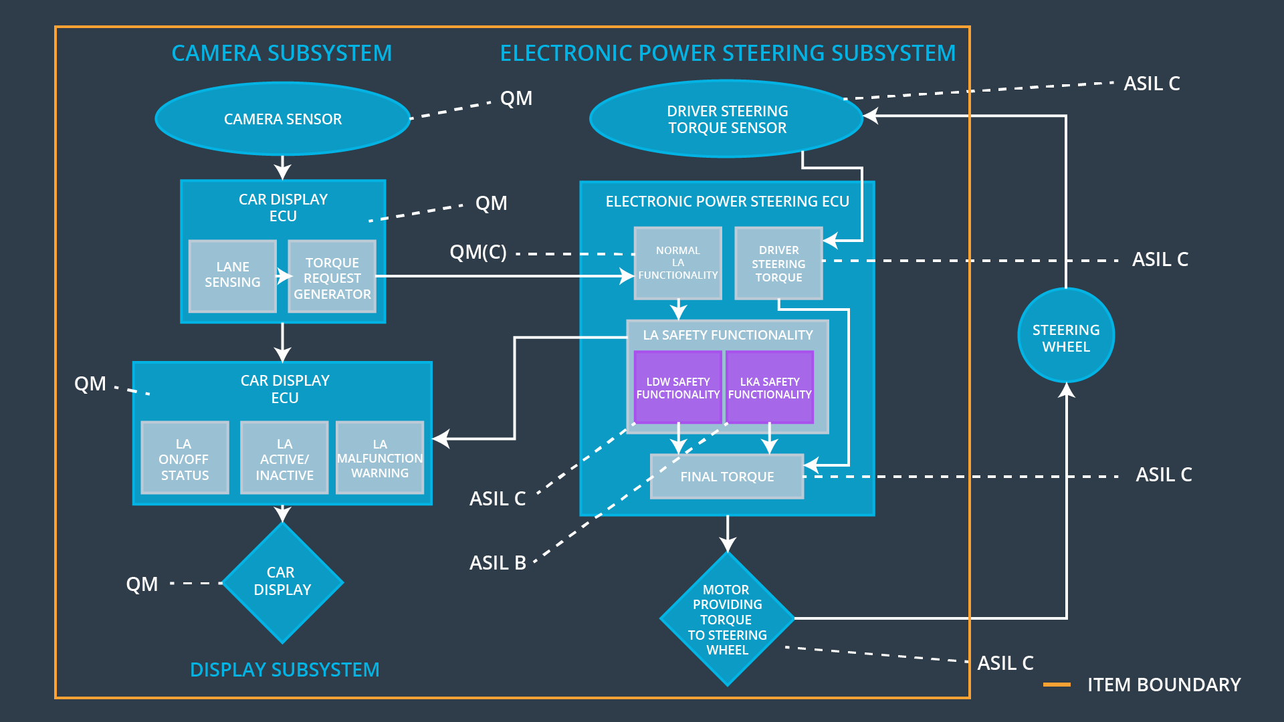

### 

### Functional overview of architecture elements

|  |  |
| --- | --- |
| **Element** | **Description** |
| Camera Sensor | Captures images of the road |
| Camera Sensor ECU - Lane Sensing | Determines when the vehicle is leaving the lane |
| Camera Sensor ECU - Torque request generator | Requests an EPS torque to correct for lane drift or an oscillating torque for driver alerting |
| Car Display | Lights up to notify driver of lane departure |
| Car Display ECU - Lane Assistance On/Off Status | Determines when to light up the dash to notify driver of lane assistance status |
| Car Display ECU - Lane Assistant Active/Inactive | Determines when to light up dash to notify driver of lane assistance being active or not |
| Car Display ECU - Lane Assistance malfunction warning | Determines when to light up dash to notify driver of a malfunction in the lane assistance item |
| Driver Steering Torque Sensor | Determines the amount, if any, that the driver is steering |
| Electronic Power Steering (EPS) ECU - Driver Steering Torque | Determines if the driver is responding to the lane departure warning or if the hands are completely off the wheel |
| EPS ECU - Normal Lane Assistance Functionality | Determines the amount of torque request to send to the motor, if determined by camera system |
| EPS ECU - Lane Departure Warning Safety Functionality | Sends an oscillating torque command to the motor at specified frequency and amplitude and sends signal to car display ECU |
| EPS ECU - Lane Keeping Assistant Safety Functionality | Sends an assitive torque command to the motor at specified amount and duration and sends signal to car display ECU |
| EPS ECU - Final Torque | Final torque sent to the motor |
| Motor | Applies torque to the steering wheel |

# Technical Safety Concept

## Technical Safety Requirements

**Lane Departure Warning (LDW) Requirements:**

Functional Safety Requirement 01-01 with its associated system elements

(derived in the functional safety concept)

|  |  |  |  |  |
| --- | --- | --- | --- | --- |
| **ID** | **Functional Safety Requirement** | **Electronic Power Steering ECU** | **Camera ECU** | **Car Display ECU** |
| Functional  Safety  Requirement  01-01 | The lane keeping item shall ensure that the lane departure oscillating torque amplitude is below Max_Torque_Amplitude | X |  |  |

Technical Safety Requirements related to Functional Safety Requirement 01-01 are:

|  |  |  |  |  |  |
| --- | --- | --- | --- | --- | --- |
| **ID** | **Technical Safety Requirement** | **ASIL** | **Fault Tolerant Time Interval** | **Architecture Allocation** | **Safe State** |
| Technical  Safety  Requirement  01 | The LDW safety component shall ensure that the amplitude of the 'LDW_Torque_Request' sent to the 'Final electronic power steering Torque' component is below 'Max_Torque_Amplitude. | C | 50 ms | LDW Safety software component of EPS ECU | The LDW torque request amplitude shall be set to zero. |
| Technical  Safety  Requirement  02 | As soon as the LDW function deactivates the LDW feature, the 'LDW Safety' software block shall send a signal to the car display ECU to turn on a warning light. | C | 50 ms | LDW Safety software component of EPS ECU | The LDW torque request amplitude shall be set to zero. |
| Technical  Safety  Requirement  03 | As soon as a failure is detected by the LDW function, it shall deactivate the LDW feature and the 'LDW_Torque_Request' shall be set to zero. | C | 50 ms | LDW Safety software component of EPS ECU | The LDW torque request amplitude shall be set to zero. |
| Technical  Safety  Requirement  04 | The validity and integrity of the data transmission for 'LDW_Torque_Request' signal shall be ensured. | C | 50 ms | Data transmission integrity check | The LDW torque request amplitude shall be set to zero. |
| Technical  Safety  Requirement  05 | Memory test shall be conducted at startup of the EPS ECU to check for any faults in memory. | A | Ignition cycle | Safety Startup Memory Test block | The LDW torque request amplitude shall be set to zero. |

Functional Safety Requirement 01-2 with its associated system elements

(derived in the functional safety concept)

|  |  |  |  |  |
| --- | --- | --- | --- | --- |
| **ID** | **Functional Safety Requirement** | **Electronic Power Steering ECU** | **Camera ECU** | **Car Display ECU** |
| Functional  Safety  Requirement  01-02 | The lane keeping item shall ensure that the lane departure oscillating torque frequency is below Max_Torque_Frequency | X |  |  |

Technical Safety Requirements related to Functional Safety Requirement 01-02 are:

|  |  |  |  |  |  |
| --- | --- | --- | --- | --- | --- |
| **ID** | **Technical Safety Requirement** | **ASIL** | **Fault Tolerant Time Interval** | **Architecture Allocation** | **Safe State** |
| Technical  Safety  Requirement  01 | The LDW safety component shall ensure that the amplitude of the 'LDW_Torque_Request' sent to the 'Final electronic power steering Torque' component is below 'Max_Frequency. | C | 50 ms | LDW Safety software component of EPS ECU | The LDW torque request frequency shall be set to zero. |
| Technical  Safety  Requirement  02 | As soon as the LDW function deactivates the LDW feature, the 'LDW Safety' software block shall send a signal to the car display ECU to turn on a warning light. | C | 50 ms | LDW Safety software component of EPS ECU | The LDW torque request frequency shall be set to zero. |
| Technical  Safety  Requirement  03 | As soon as a failure is detected by the LDW function, it shall deactivate the LDW feature and the 'LDW_Torque_Request' shall be set to zero. | C | 50 ms | LDW Safety software component of EPS ECU | The LDW torque request frequency shall be set to zero. |
| Technical  Safety  Requirement  04 | The validity and integrity of the data transmission for 'LDW_Torque_Request' signal shall be ensured. | C | 50 ms | Data transmission integrity check | The LDW torque request frequency shall be set to zero. |
| Technical  Safety  Requirement  05 | Memory test shall be conducted at startup of the EPS ECU to check for any faults in memory. | A | Ignition cycle | Safety Startup Memory Test block | The LDW torque request frequency shall be set to zero. |

**Lane Keeping Assistance (LKA) Requirements:**

Functional Safety Requirement 02-1 with its associated system elements

(derived in the functional safety concept)

|  |  |  |  |  |
| --- | --- | --- | --- | --- |
| **ID** | **Functional Safety Requirement** | **Electronic Power Steering ECU** | **Camera ECU** | **Car Display ECU** |
| Functional  Safety  Requirement  02-01 | The lane keeping item shall ensure that the lane keeping assistance torque is applied for only Max_Duration | X |  |  |

Technical Safety Requirements related to Functional Safety Requirement 02-01 are:

|  |  |  |  |  |  |
| --- | --- | --- | --- | --- | --- |
| **ID** | **Technical Safety Requirement** | **ASIL** | **Fault Tolerant Time Interval** | **Allocation to Architecture** | **Safe State** |
| Technical  Safety  Requirement  01 | The Lane Keep Assist safety component shall ensure that the duration of the 'LKA_Torque_Request' sent to the 'Final electronic power steering Torque' component is below 'Max_Duration’. | B | 500 ms | LKA Safety software component of EPS ECU | The LKA torque request shall be set to zero. |
| Technical  Safety  Requirement  02 | As soon as the LKA function deactivates the LKA feature, the 'LKA Safety' software block shall send a signal to the car display ECU to turn on a warning light. | B | 500 ms | LKA Safety software component of EPS ECU | The LKA torque request shall be set to zero. |
| Technical  Safety  Requirement  03 | As soon as a failure is detected by the LKA function, it shall deactivate the LKA feature and the 'LKA_Torque_Request' shall be set to zero. | B | 500 ms | LKA Safety software component of EPS ECU | The LKA torque request shall be set to zero. |
| Technical  Safety  Requirement  04 | The validity and integrity of the data transmission for 'LKA_Torque_Request' signal shall be ensured. | B | 500 ms | Data transmission integrity check | The LKA torque request shall be set to zero. |
| Technical  Safety  Requirement  05 | Memory test shall be conducted at startup of the EPS ECU to check for any faults in memory. | A | Ignition cycle | Safety Startup Memory Test block | The LKA torque request shall be set to zero. |

## Refinement of the System Architecture

The refined system architecture is shown below. It consists of modified ECU blocks which specify what signals are sent, safety checks, and ASIL scores for each individual component.

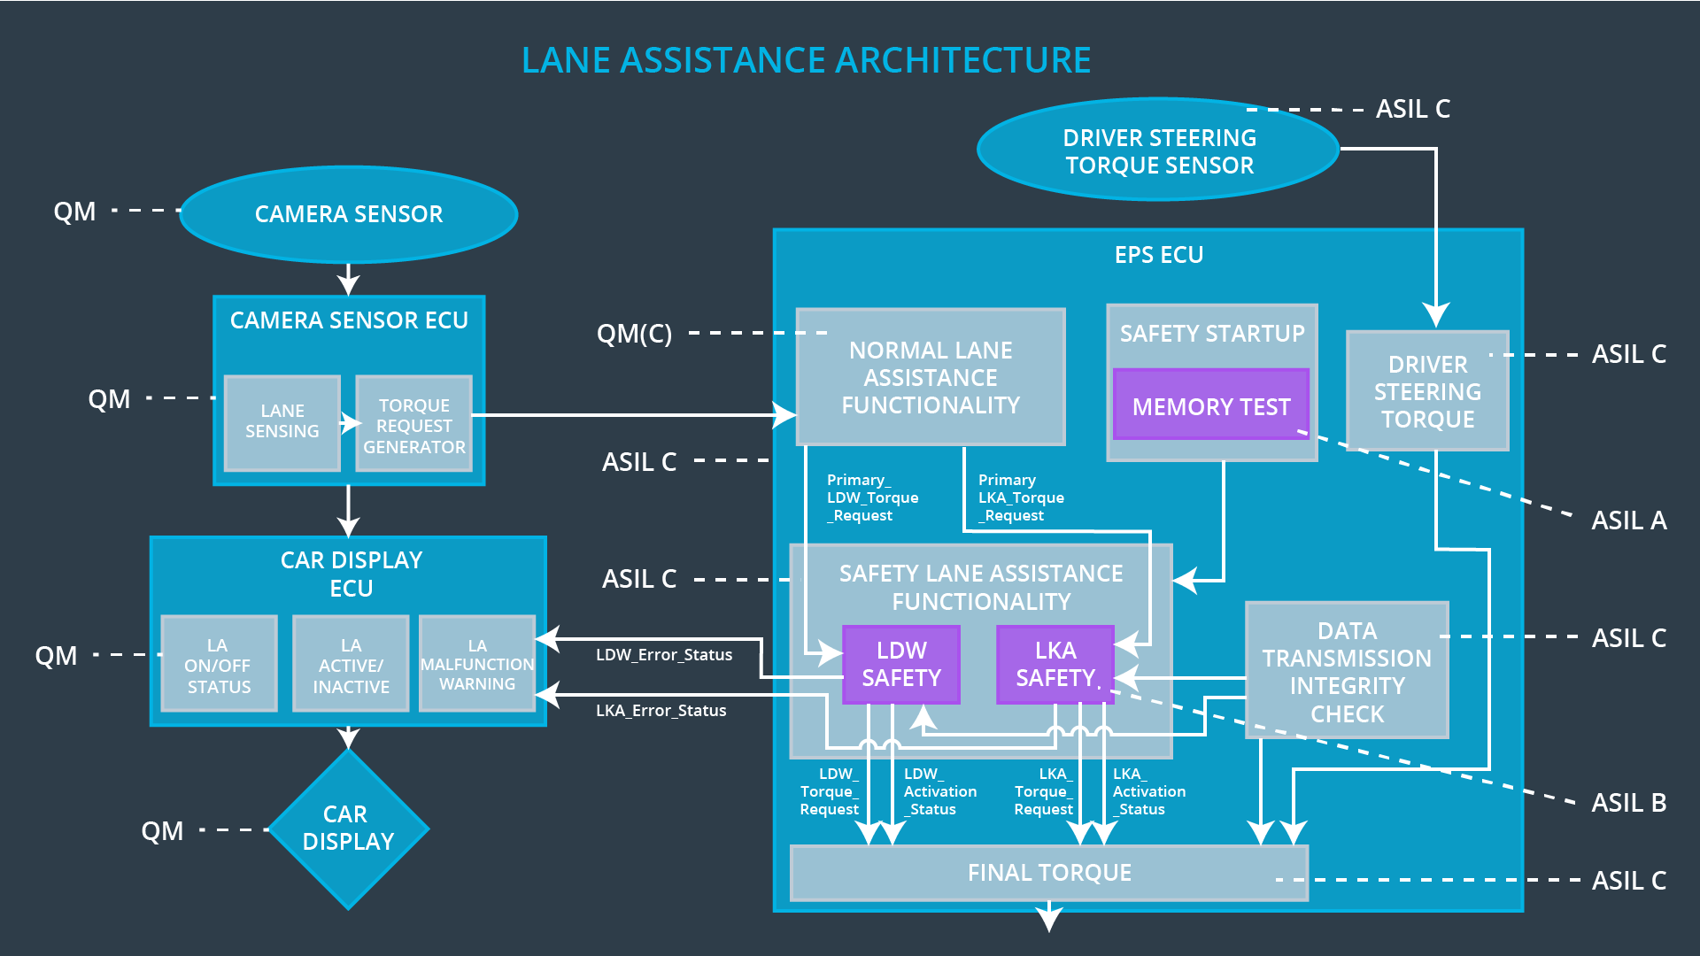

## Allocation of Technical Safety Requirements to Architecture Elements

For the lane assistance item, all technical safety requirements are allocated to the Electronic Power Steering ECU.

## Warning and Degradation Concept

|  |  |  |  |  |
| --- | --- | --- | --- | --- |
| **ID** | **Degradation Mode** | **Trigger for Degradation Mode** | **Safe State invoked?** | **Driver Warning** |
| WDC-01 | Turn off functionality | Malfunction_01 & Malfunction_02 | Yes | Warning light on the dash |
| WDC-02 | Turn off functionality | Malfunction_03 | Yes | Warning light on the dash |